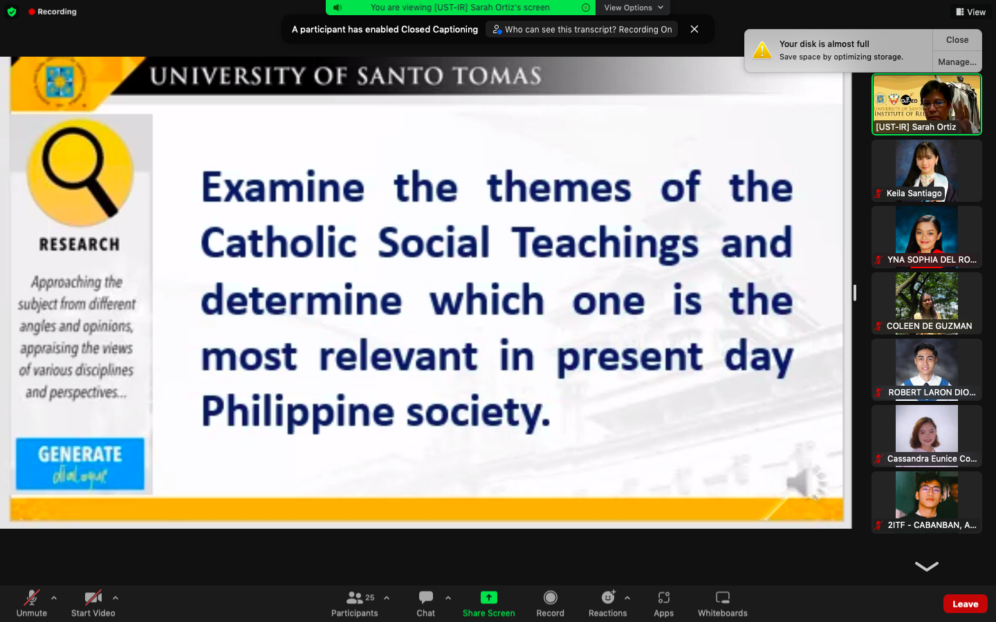

bet q kayo ba? Sige lang

<https://ccsww.org/about-us/catholic-social-teaching/>

The most relevant theme of the Catholic Social Teachings in the Philippines is The Dignity of Work and the Rights of Workers. In order for the economy to function properly, it must serve people rather than the other way around. In addition to making a living, work is a form of continuing participation in the creation of God. It is a necessity in order for us to thrive and survive. It is a path to growth, human development, and personal fulfillment. Thus, the rights and dignity of workers must be respected. To safeguard the dignity of work, we must respect the basic rights of workers, such as the right to productive work, decent and fair wages, the right to organize and join unions, and the right to economic initiative.

In today's global society, it is important to prioritize steady employment for everyone, regardless of the limited interests of business. Work is really hard to come by and sometimes, looking for work is still affected by status, whereas if you don't have any connections to people with power it would be alot more difficult to find a sustainable job. It is necessary that people would get proper jobs that would reward both the company and the employee equally for one should not benefit over the other. Poverty results from a violation of the dignity of human effort when employees are not paid a fair wage, putting their lives at danger in order to support their families. To deprive others to work is to deprive them of continuing to participate in God’s creation. No one should be deprived of that. That’s why Catholics believe in the Dignity of Work and the Rights of Workers.